M07 Chapter 13 Hands On Submission

- Hands-On Project 13-1
  - Use Chapter 13 Trace File: Web site downDownload Chapter 13 Trace File: Web site down
  - Screenshot showing the expert information information (step 3)
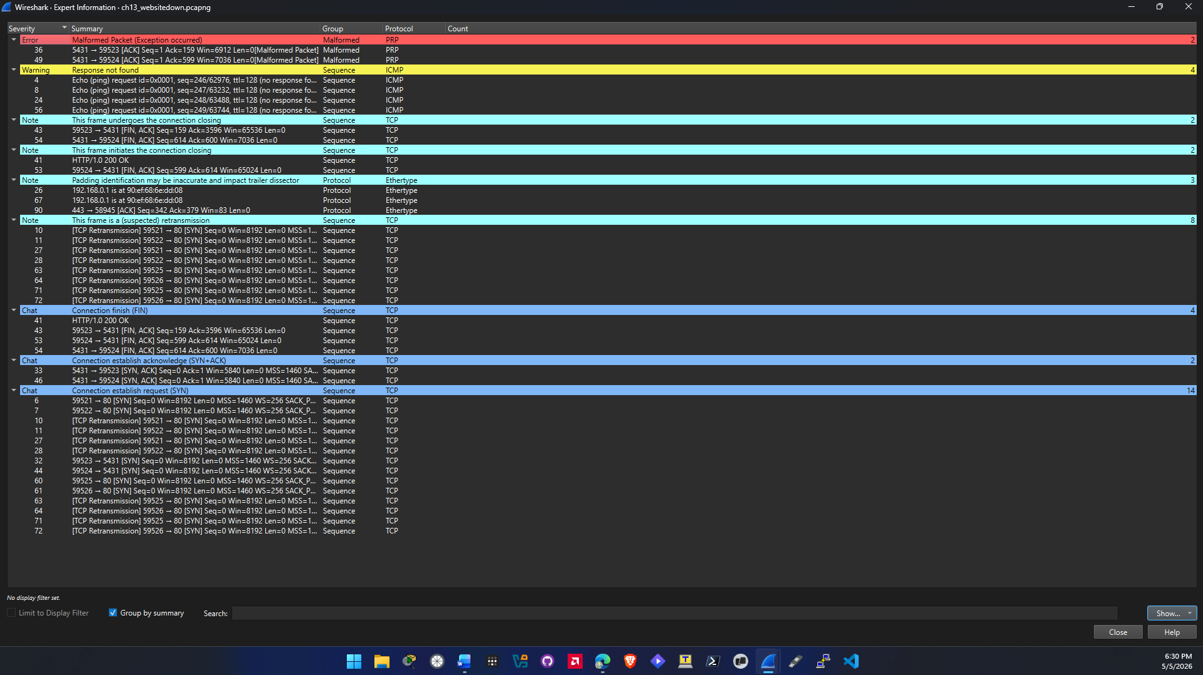
  - Screenshot showing the I/O graph information (step 5)
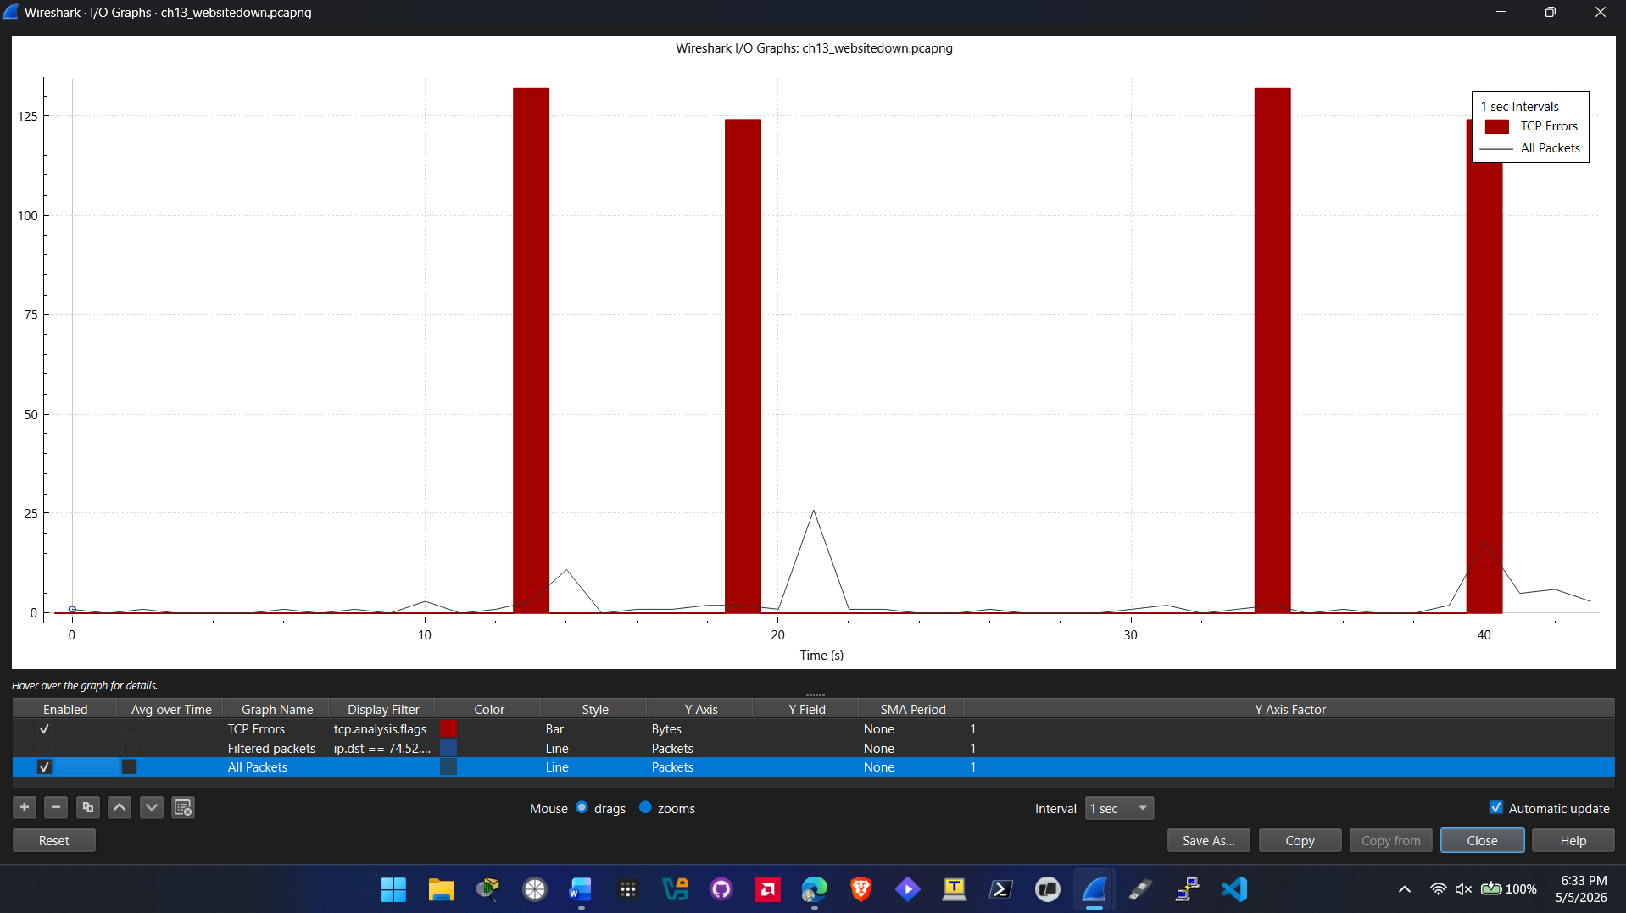
  - Screenshot showing the I/O graph information of only TCP errors (step 6)
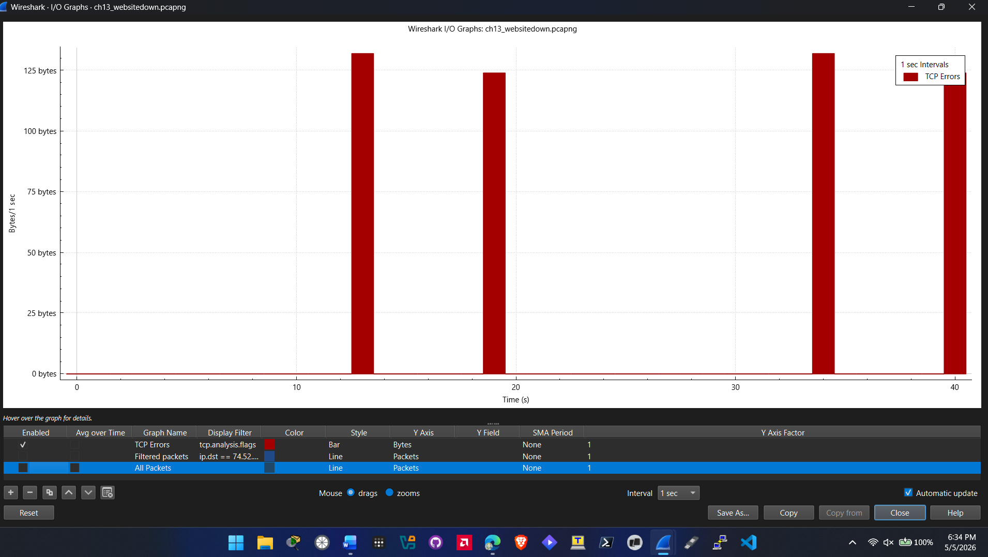
  - Screenshot of a packet you pull up from step 9
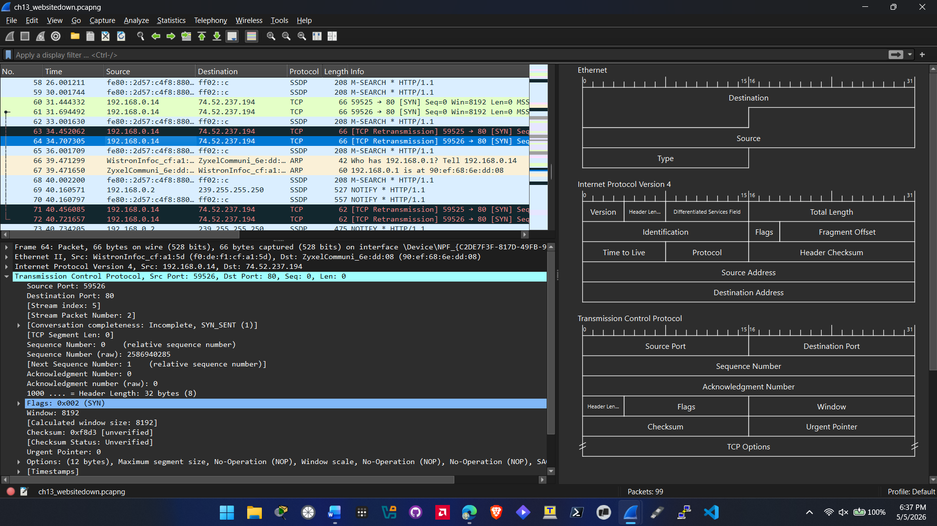

- Hands-On Project 13-2
  - Use Chapter 13 Trace File: Chatty Windows 10Download Chapter 13 Trace File: Chatty Windows 10
  - Screenshot showing packet 379 expanded (step 3)
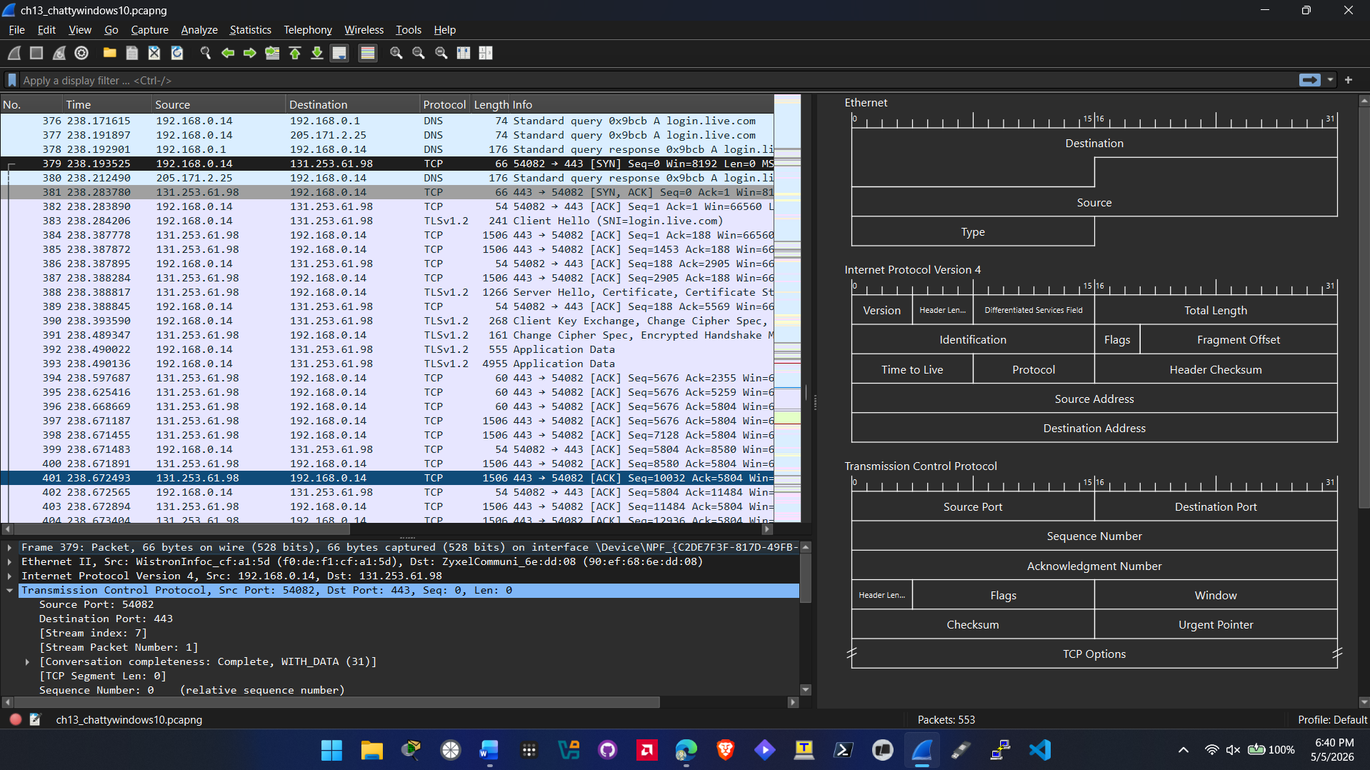
  - Screenshot of results of the web search (step 6)
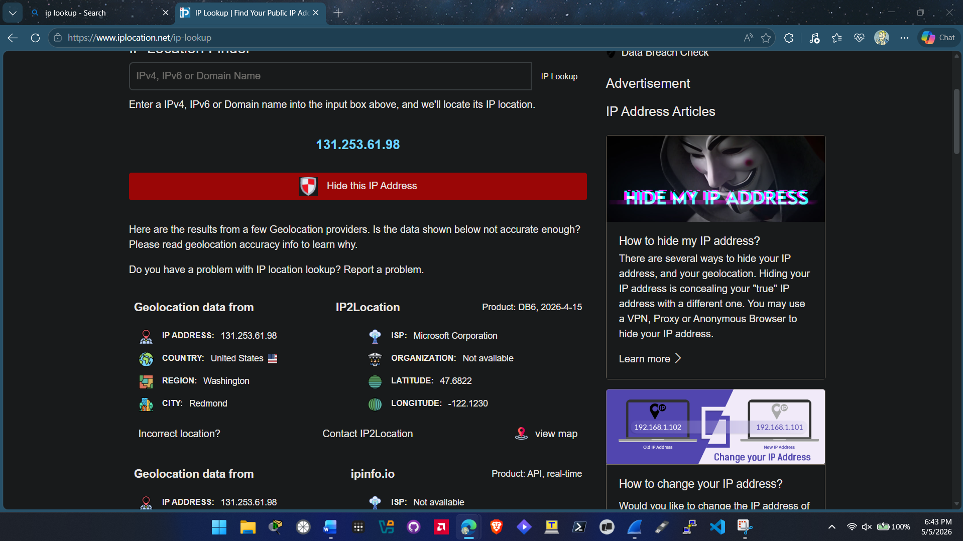
  - Screenshot of tracert results (step 7)
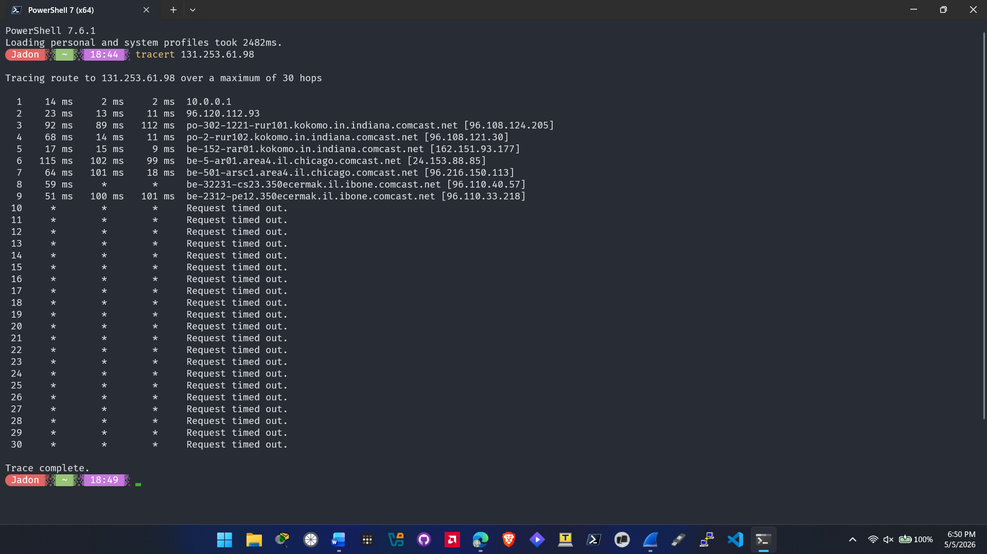
  - Screenshot of packet 392 with the details expanded (step 8)
